### **Purvi - Sakila Challenge**

### 

### **1) List all actors.**

SELECT first_name, last_name

FROM actor;



### **2) Find the surname of the actor with the forename 'John'.**

SELECT last_name

FROM actor

WHERE first_name='John';



### **3) Find all actors with surname 'Neeson'.**

SELECT first_name, last_name

FROM actor

WHERE last_name='Neeson';



### **4) Find all actors with ID numbers divisible by 10.**

SELECT first_name, last_name

FROM actor

WHERE actor_id % 10 = 0;



### **5) What is the description of the movie with an ID of 100?**

SELECT description

FROM film

WHERE film_id=100;

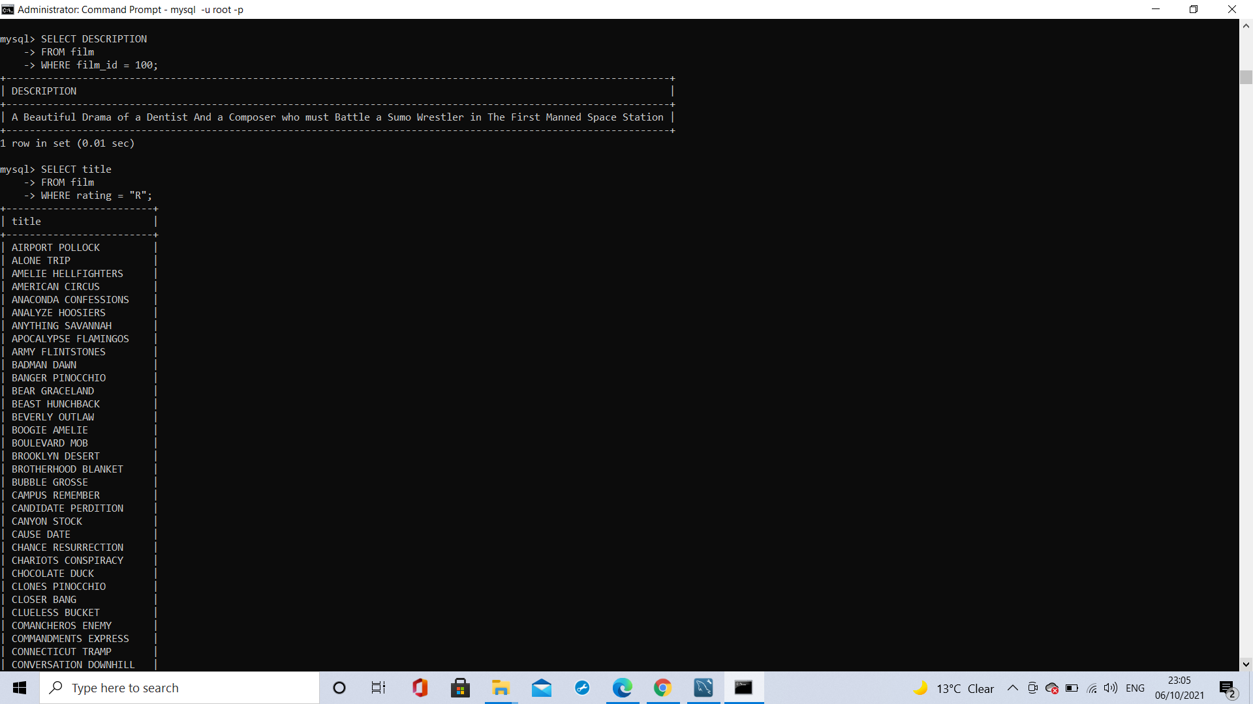

### **6) Find every R-rated movie.**

SELECT title

FROM film

WHERE rating='R';



### **7) Find every non-R-rated movie.**

SELECT title

FROM film

WHERE rating!='R';



### **8) Find the ten shortest movies.**

SELECT title, length

FROM film

ORDER BY length ASC

LIMIT 10;



### **9) Find the movies with the longest runtime, without using LIMIT.**

SELECT title, length

FROM film

WHERE length= (

SELECT max(length)

FROM film);



### **10) Find all movies that have deleted scenes.**

SELECT title

FROM film

WHERE special_features='Deleted Scenes';



### **11) Using HAVING, reverse-alphabetically list the last names that are not repeated.**

SELECT DISTINCT last_name

FROM actor

HAVING last_name IS NOT NULL

ORDER BY last_name DESC;



### **12) Using HAVING, list the last names that appear more than once, from highest to lowest frequency.**

SELECT last_name, COUNT(last_name)

FROM actor

GROUP BY last_name

HAVING COUNT(last_name) > 1

ORDER BY COUNT(last_name) DESC;



### **13) Which actor has appeared in the most films?**

SELECT actor_info.first_name, actor_info.last_name

FROM actor_info

JOIN film_actor ON actor_info.actor_id=film_actor.actor_id

GROUP BY actor_info.actor_id

ORDER BY COUNT(*) DESC

LIMIT 1;

OR

SELECT CONCAT(" ",actor.first_name, " ", actor.last_name) AS Full_name, COUNT(actor.actor_id) as No_of_Movies

FROM actor Inner

JOIN film_actor ON actor.actor_id = film_actor.actor_id

GROUP BY actor.actor_id

ORDER BY count(film_actor.actor_id) DESC LIMIT 1;



### **14) When is 'Academy Dinosaur' due?**

SELECT film.title, DATE_ADD(rental.rental_date, INTERVAL film.rental_duration DAY) AS due_date

FROM film

LEFT OUTER JOIN inventory ON film.film_id = inventory.film_id

LEFT OUTER JOIN rental ON rental.inventory_id = inventory.inventory_id

WHERE film.title = "Academy Dinosaur"

AND rental.return_date IS NULL

AND rental.rental_date IS NOT NULL;



### **15)What is the average runtime of all films?**

SELECT AVG(length)

FROM film;



### **16) List the average runtime for every film category.**

SELECT category.name, AVG(film.length)

FROM category

JOIN film_category ON film_category.category_id=category.category_id

JOIN film ON film.film_id=film_category.film_id

GROUP BY category.category_id

ORDER BY AVG(film.length) DESC;



### **17) List all movies featuring a robot.**

SELECT film.title

FROM film_text

JOIN film ON film.film_id=film_text.film_id

WHERE film_text.description LIKE '%robot%';

OR

SELECT title

FROM film

WHERE description LIKE "%robot%";



### **18) How many movies were released in 2010?**

SELECT COUNT(release_year) AS 2010_films

FROM film

WHERE release_year=2010;



### **19) Find the titles of all the horror movies.**

SELECT film.title

FROM category

JOIN film_category ON film_category.category_id=category.category_id

JOIN film ON film_category.film_id=film.film_id

WHERE category.name='Horror';



### **20) List the full name of the staff member with the ID of 2.**

SELECT first_name, last_name

FROM staff

WHERE staff_id=2;



### **21) List all the movies that Fred Costner has appeared in.**

SELECT film.title

FROM film

JOIN film_actor ON film_actor.film_id=film.film_id

JOIN actor ON actor.actor_id=film_actor.actor_id

WHERE actor.first_name='FRED' AND actor.last_name='Costner';



### **22) How many distinct countries are there?**

SELECT DISTINCT COUNT(country) AS distinct_countries

FROM country;



### 

### **23) List the name of every language in reverse-alphabetical order.**

SELECT name

FROM language

ORDER BY name DESC;



### **24) List the full names of every actor whose surname ends with '-son' in alphabetical order by their forename.**

SELECT first_name, last_name

FROM actor

WHERE last_name LIKE '%son'

ORDER BY first_name ASC;



### **25) Which category contains the most films?**

SELECT category.name

FROM category

JOIN film_category ON film_category.category_id=category.category_id

GROUP BY category.category_id

ORDER BY COUNT(film_category.category_id) DESC

LIMIT 1;

